Lithol Rubine (Calcium)

Color Type Monoazo Lake
Color Index No. P.R.57:1 CAS NO. 5281-04-9

Structure:

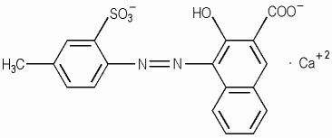Description：
- There are many different color shades from yellowish to bluish products for offset inks.
- W5713 is semi-transparent high gloss for water-based ink.
- S5714 is bluish 4BGL for Solvent-based ink with low viscosity and high gloss.
- S5715 is yellowish for Solvent-based ink.
- P5711 Rubine 4BP is superfine grinding for plastic and powder coating.

Physical properties and Fastness：
Density (g/cm3) | 1.65-2.11
Oil absorption (ml/100g) | 45±5
Water soluble matter (%) | ≤2.5
PH Value | 6.5-8.0
Heat Resistance (°C) | 160~220°C
Light Fastness | 5
Water Resistance | 4
Oil Resistance | 4
Acid Resistance | 4
Alkali Resistance | 4~5
Alcohol Resistance | 4
Migration | 4

Color card:
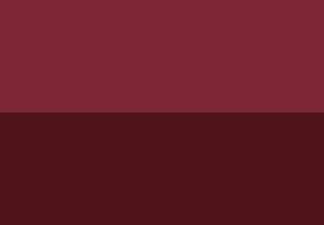

Applications：

Inks | Offset Ink | ●
Inks | Water Based Ink | ●
Inks | Solvent Based Ink | ●
Plastic | PVC/LDPE | ●
Paint | Decorative Paint | ○
Paint | Powder Coating | ●
Remark: ●High Recommendation;
○Recommendation; -Limit Suitability

Storage conditions：
Should be sealed for avoiding light and moisture.

Package：
25kgs craft bag with Carton box on pallet.

Please note: ***This technical index and recommending application information is based on the present knowledge for reference only. Necessary test is needed before you put into use. ***

